Question Form

Questioner: Xiaogeng Xu
Affiliation: Beijing University of Posts and Telecommunications
Operation System: Ubuntu 12.04
Boost Version: 1.48
Submit Date: 2014-05-28

Question
Why does the constant value of a customized parameter of Interest change after one-hop transmission?

- Question Description
We defined a customized parameter to Interest, and traced this parameter during simulation. The parameter was supposed to be constant during the simulation. However, we found that the parameter was set to 0 after one-hop transmission. We wondered that the parameter was rewritten before transmission, maybe when the Interest is packaged.
Therefore, our question is as follows:
  - Whether parameter is reset before transmitting Interest?
  - How to give value to a customized parameter and keep this value constant during its lifetime?
  - If more codes need to be edit to set a parameter of Interest, which files are supposed to be edit?

- Problem Reproduction
The problem can be reproduced according to the following procedure.
  - Announce ‘m_icid’ as a customized parameter to Interest in ndn-interest.h. The red bold characters are added.
------------------------------- ndn-interest.h -----------------------------------------
private: //line 236
Ptr<Name> m_name; ///< @brief Interest name
uint8_t m_scope; ///< @brief 0xFF not set, 0 local scope, 1 this host, 2 immediate neighborhood
Time m_interestLifetime; ///< @brief InterestLifetime
uint32_t m_nonce; ///< @brief Nonce. not used if zero
uint8_t m_nackType; ///< @brief Negative Acknowledgement type
Ptr<Exclude> m_exclude; ///< @brief Exclude filter
Ptr<Packet> m_payload; ///< @brief virtual payload
mutable Ptr<const Packet> m_wire;
uint32_t m_icid; ///< @brief add m_icid (Community ID) to Interest
------------------------------------------------------------------------------------

  - Two functions are defined into ndn-interest.cc. The red bold characters are added.
------------------------------- ndn-interest.cc ---------------------------------------------
Ptr<const Exclude> //line 147
Interest::GetExclude () const
{
return m_exclude;
{
void
SetCommunityId(uint32_t icid); //set icid
uint32_t
GetCommunityId() const; //read icid
------------------------------------------------------------------------------------

  - Call ‘SetCommunityId’ in ndn-consumer.cc to set value to ‘icid’. The red bold characters are added.
------------------------------- ndn-consumer.cc --------------------------------------------
Ptr<Interest> interest = Create<Interest> (); //line 201
interest->SetNonce (m_rand.GetValue ());
interest->SetName (nameWithSequence);
interest->SetInterestLifetime (m_interestLifeTime);
interest->SetCommunityId (1); // set icid=1
------------------------------------------------------------------------------------

  - Add commands in ndn-forwardingstrategy.cc to print ‘nonce’ and ‘icid’ of the received Interest. The red bold characters are added.
------------------------------- ndn-forwardingstrategy.cc ---------------------------
void
ForwardingStrategy::OnInterest (Ptr<Face> inFace, Ptr<Interest> interest)
{
NS_LOG_FUNCTION (inFace << interest->GetName ()); //line 145
std::cout<<"interest nonce: " <<interest->GetNonce() <<std::endl;
std::cout<<"interest community ID:"<<interest->GetCommunityId()<<std::endl; // print ‘nonce’ and ‘icid’ of the received Interest
m_inInterests (interest, inFace);
------------------------------------------------------------------------------------

  - Run ndn-simple.cc (unchanged). The simulation result is shown as below:
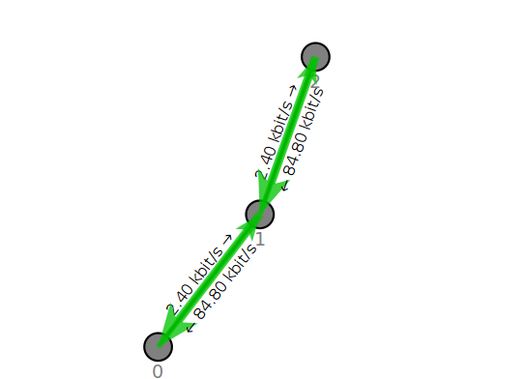
Fig.1 The Topology Output of ndn-simple.cc

Node 0
Node 1
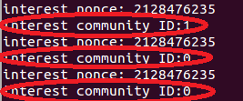
Node 2

Fig. 2 Output of nonce and community ID of the received Interest

Fig. 2 shows that the community ID was 1, just as being set in program. However, the community ID of the same Interest change back to 0 in both Node 2 and Node 3. We wonder that the community ID was rewritten to 0 when the Interest is re-packaged. Is it true? If it is, where is the value reset?

  - In order to find out the locations that related to setting values such as ‘name’, ‘nonce’, and ‘scope’ etc. We try to look for programs which include functions of ‘SetXXX’. The result feedback of our search is shown as follows. It presents that several codes do ‘SetXXX’ in our simulation platform. Does it mean that once we create a new parameter to Interest, we need to update all these files? Or maybe, there are one or some codes that actually set value, and we are supposed to edit those files only? Which ones?

-----------------------------Search Result-------------------------------------------------------
./src/ndnSIM/examples/custom-apps/custom-app.cc
./src/ndnSIM/examples/custom-apps/dumb-requester.cc
./src/ndnSIM/apps/ndn-consumer.cc
./src/ndnSIM/apps/ndn-consumer-zipf-mandelbrot.cc
./src/ndnSIM/test/ndnSIM-pit.cc
./src/ndnSIM/test/ndnSIM-serialization.cc
./src/ndnSIM/test/ndnSIM-fib-entry.cc
./src/ndnSIM/ndn.cxx/ndn-api-face.cc
./src/ndnSIM/model/wire/ccnb/wire-ccnb-interest.cc
./src/ndnSIM/model/wire/ndnsim.cc
------------------------------------------------------------------------------------

