Hello, I have encountered some questions about ndn forwarding ,so I want to ask you for advice:
In paper Flow-based NDN Architecture, we propose a flow-based NDN architecture (fNDN). which can not only achieve overload decreasing by packing successive Interest packets but also performance improvement and load-balance by multi-path. The main idea is to pack the interest:
When a user requests a content(data), he needs to send many interests. We can put many interests into an interest package, so that a f-interest can achieve the function of many interests to request more Data packets. But in ndn forwarding function ,the function Face :: expressInterest () is set to send a Interest, Facd :: expressInterest () to receive a data packet, then the function will be finished.
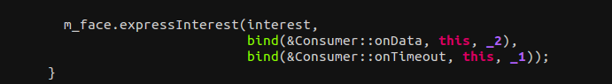
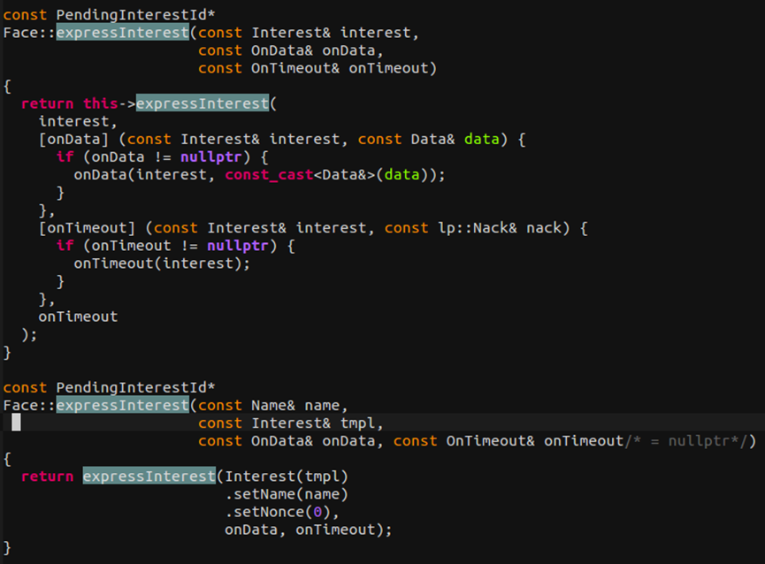
But the idea of f-ndn is to send a f-interest to request many datas, which needs Face :: expressInterest () receive multiple data package before the function is over, but this feature/function can not be achieved in Face :: expressInterest () .
What I would like to ask is that,where does our idea go wrong? our idea and ndn the original network layer architecture is contradictory, or that only a matter of the code.If the code is the problem, we have modified the code, but each compile will collapse, can you have any suggestion?

